Instructions for writing conference papers (the title – Times new Roman, 16 – pt, bold, aligned left margin)

PhD Ivan Horvat, college professor, Šibenik University of Applied Sciences, ivan.horvat@vus.hr
MA Ana Anić, senior lecturer, Šibenik University of Applied Sciences, ana.anic@vus.hr

ABSTRACT

Use this file as a template. Since the abstract is often presented separately from the article, it should be able to stand alone. The abstract should include the research's aim, significant outcomes, and primary conclusions. Avoid using references and non-standard or unusual abbreviations. The abstract must be between 200 and 300 words long.

Keywords: keyword 1, keyword 2… keyword 5 (List three to five relevant and specific keywords that are commonly used within the subject area.)

- INTRODUCTION
All papers should have an introduction section which should include a description of the main problems, purpose and objectives of the work. An introduction should not just be a copy of an abstract. The introduction chapter is the first chapter in the paper and must be marked by the ordinal number.
The titles of all main chapters have to be marked with ordinal numbers: 1., 2., 3., .... and written in Times New Roman, font size 12-pt, bold letters, aligned with the left margin.
The spacing between chapters should be two empty lines, and between sub-chapters and sub sub-chapters it should be one empty line.
The whole text should be written in Times New Roman, 12-pt, line spacing 1.0 and aligned on both sides (justify). Margins must be set at 2.5 cm.

  - Subchapters

    - Sub sub-chapters
Subchapters and sub-subchapters have to be written as shown in this example. Subchapters titles should be written in Times new Roman, 12-pt, italic. Sub subchapters titles should be written in Times New Roman, 12-pt.

- EXTENT OF THE PAPER
The paper should be from 8 to 12 pages long, A4 paper format (including the abstract, all the chapters, a list of references, figures, tables, graphs etc.).

- CITING
When quoting or referring to a book or author it is recommended to cite the sources directly within the text itself (Petrić, 2011, 29) and if there are three or more authors, it is not necessary to list all authors (Petrić et al., 2011, 29).

- FIGURES, TABLES AND GRAPHS
Figures, tables and graphs should be written in black and white or in color and marked as follows:

Table 1: The name of the table
Source: Times New Roman, 10pt

The font of text in tables, figures and graphs has to be Times New Roman, 10-pt, line spacing 1.0.

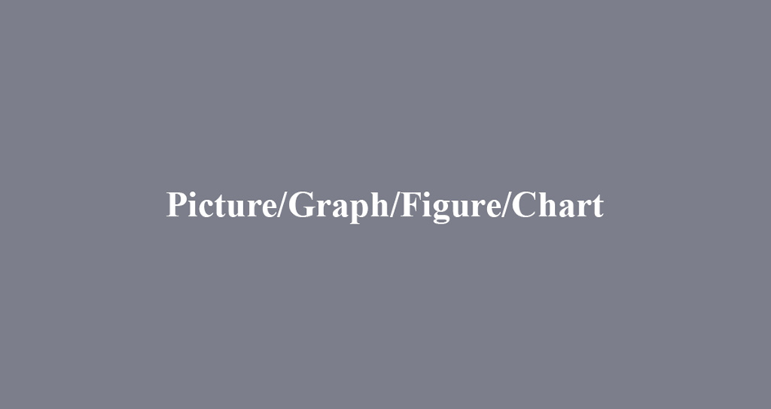
Figure/Graph 1: The name of the figure or graph
Source: Times New Roman, 10pt

Bulleted lists should look like this:
- First bullet;
- Second bullet;
- Third bullet.
Numbered lists should be added as follows:
- First item;
- Second item;
- Third item.

- CONCLUSION
The conclusion is an obligatory part of the paper. It specifies the concluding observations, the advantages and disadvantages of proposed solutions and the like. The conclusion should not be a copy of the abstract.

LITERATURE:
The bibliography should be marked by the ordinal numbers 1., 2., 3., and specified by the alphabetical order (Times New Roman, 12-pt, line spacing 1,0):
- Gardijan, P. (2009). Marketing management of companies, tourist organizations and destinations 1. Šibenik: Polytechnic of Šibenik (e.g. for books)
- Matutinović, I. (2016). Održivost i etika. U: B. Jalšenjak, K. Krkač, (ur.), Poslovna etika, korporacijska društvena odgovornost i održivost, 2. prepravljeno i prošireno izdanje (241-279). Zagreb: Mate d.o.o.. (e.g. chapter in a book)
- Pečarić, M., Filipović, I. i Krajina, D. (2011). Analiza utjecaja koncentracije bankovnog sustava na profitabilnost banaka u RH.Zbornik radova Veleučilišta u Šibeniku, 5(1-2), 20-36. (e.g. papers in journals)
- Mečev, D.,Goleš, D., Vudrag, N. (2013). Analiza kvalitete web stranica hotela s 3 i 4 zvjezdice na području Šibensko-kninske županije.U: Radić Lakoš, T. i sur. (ur.), 1. znanstvenostručna konferencija s međunarodnim sudjelovanjem „Izazovi današnjice: turizam danas - za sutra“. Šibenik:Veleučilište u Šibeniku, 472-480.(e.g. published presentation from a convention/conference)
- Romić, T. (2014). Zabavljaju li se zastupnici na račun radnika?Večernji list. 13.prosinac. Retrieved from: http://www.vecernji.hr/hrvatska/zabavljaju-li-se-zastupnici-na-racun-radnika-979031 (accessed: 13.02.2022.). (e.g. articles in newspapers)
- Rosen, C. S., Henson, B. R., Finney, J. W., Moos, R. H. (2000). Consistency of self-administered and interview-based Addiction Severity Index composite scores. Addiction, 95, 419-424. (e.g. papers in journals)
- American Physical Therapy Association. (2007). Professionalism. Retrieved from http://apta.org/Professionalism/(accessed: 13.02.2022.) (e.g. Internet website)
- Kazneni zakon (“Narodne novine”, br. 125/11., 144/12., 56/15., 61/15. – ispravak, 101/17., 118/18. i 126/19.) (in English: Criminal Law, official Gazette “Narodne novine”) (e.g. for Laws, Regulations and similar)

